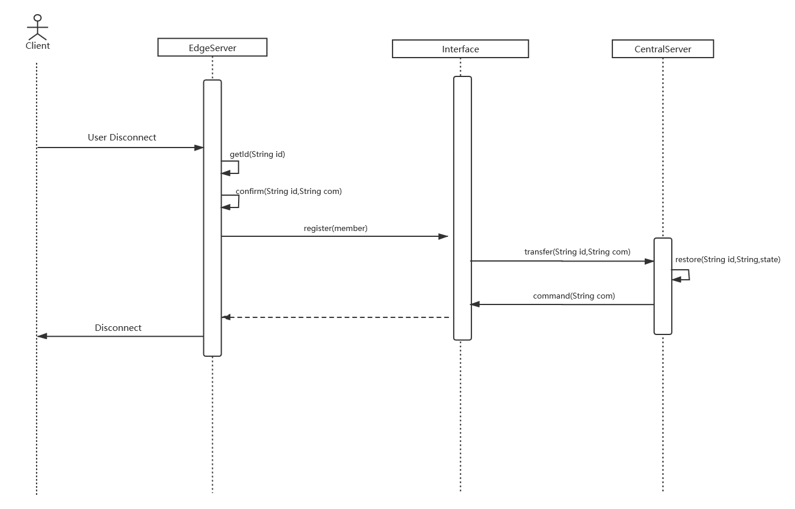

When user disconnect the server,the central server communicate with the specific edge server via the interface as a transfer station.At the beginning,the edge server send the confirm information to the central server to identify weather disconnect or not as well as send the information of itself which is used for central server to record the statement.Next,the interface transfer the information to the central server.After the central server receive the messages,it send the disconnect command and record the statue of the edge server.The interface transfer the disconnect command and then the edge server disconnect from the central server.

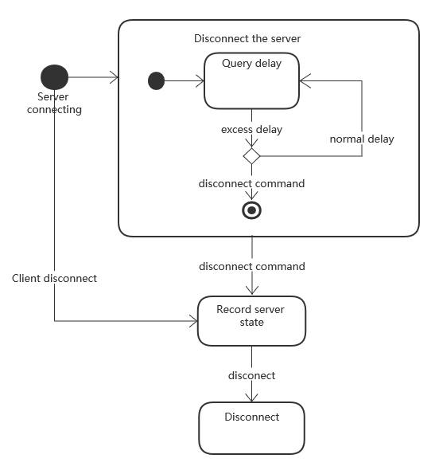

While server connecting,the edge server check itself delay and disconnect the server when the delay excess the standard level.When server execute the disconnect command, the central server send disconnect command to the edge server and record the state.